Chapter 9, Solution 74.

One such RL circuit is shown below.
We now want to show that this circuit will produce a 90 phase shift.
20 
20 
j20 
j20 
V
+
V_{i} = 10
−

+
V_{o}
−

Z

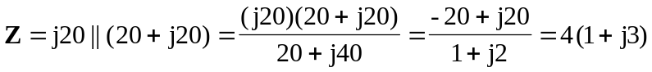

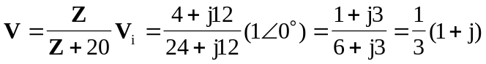

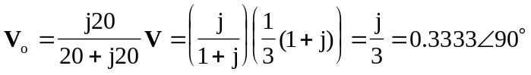

This shows that the output leads the input by 90.

